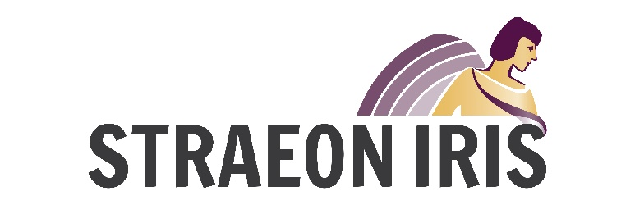

2017/18 APPLICATION FORM: Straeon Iris Dau
Background
The Iris Prize is supported by The Michael Bishop Foundation and continues to be the only LGBT short film prize in the world which allows the winner to make a new film. Iris is what film makers need – funding, support and guidance. The winner receives £30,000 to make their next short film in Wales. 8 short films have been produced to date in collaboration with the winning filmmakers of the Iris Prize. The 9th short is currently in pre-production.

Welsh Language LGBT Content
As part of the 10th anniversary celebrations in 2016 the Iris Prize in partnership with S4C and Ffilm Cymru Wales created Straeon Iris to support the production and exploitation of new LGBT short films in the Welsh language. Straeon Iris is open to individual writers and also writer and director teams to support the production of one short film.

The inaugural Straeon Iris was awarded to writer Bethan Marlow. Her project Afiach follows a young lesbian couple waiting on a platform for the arrival of a train as they reflect on mortality and face death head on. The director was Carys Lewis, originally from Wales, but now living in Toronto, Canada.

STRAEON IRIS
The aim of the scheme is to encourage more LGBT stories for the screen, from Wales, about Wales, and in Welsh. The scheme will focus on developing up to six short film scripts (max 10 mins duration) before selecting one to go into production. The scheme will encourage new writers but will also be open to experienced writers.
Executives from S4C (Gethin Scourfield), Ffilm Cymru Wales (Tracy Spottiswoode) and the Iris Prize (Berwyn Rowlands) will select the script to go into production.

The Iris Prize will produce the short film.

Key Dates:
2017
- Friday 9 August: Scheme launch at Sinemaes, National Eisteddfod, Ynys Môn.
- October 10 – 15: All applicants will be encouraged to attend the Iris Prize Festival
- November 1: Closing date for applications
- December 12: Confirm the names of the projects to be developed further (max 6)

2018
- January / March: Development period for the shortlisted projects
- March 26: Confirm the script to be filmed
- Summer 2018: Production and post of the short film
- October 9, 2018: Premier of short film, Opening Night, Iris Prize Festival 2018

Application Process:
Closing date: Wednesday 1 November 2017.
Applications invited from new or experienced Welsh language writers and writer / director teams.
Application to include the name of potential director (this could be the same as the writer)
A first draft script must be included with the application.
Link to director’s show-reel to be included with application.

APPLICATION FORM: Please complete all sections:
Name of writer: Cliciwch yma i deipio testun.
E-mail: Cliciwch yma i deipio testun.
Phone: Cliciwch yma i deipio testun.
Address: Cliciwch yma i deipio testun.

Name of director (if relevant): Cliciwch yma i deipio testun.
e-mail: Cliciwch yma i deipio testun.
Phone: Cliciwch yma i deipio testun.
Address: Cliciwch yma i deipio testun.

Have you included a first draft copy of the script? Cliciwch yma i deipio testun.
Have you supplied links to the director’s show-reel?Cliciwch yma i deipio testun.
Further Details: Berwyn Rowlands
berwyn@irisprize.org
Tel: 029 20232744
Mobile: 07860 818294

