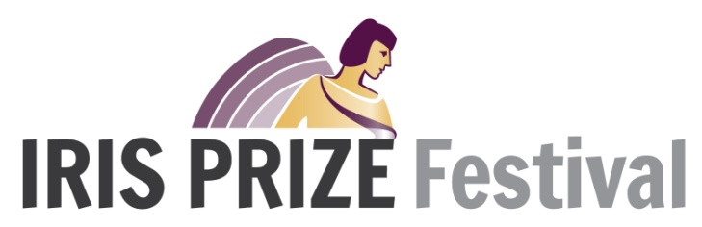
Volunteer Application Form 9 - 14 October 2018

Please complete the following form and return by email to francis@irisprize.org or by post to: Iris Prize Festival, Ty Cefn, Rectory Road, Cardiff CF5 1QL

Data on this form will be processed by The Festivals Company Limited only for the purpose of assessing your application to volunteer at the 2018 Iris Prize Festival. The Festivals Company may occasionally send you information about other Iris related events you may be interested in; if you prefer not to receive this information please mark this box with a cross:

NAME:

We receive a growing number of requests to volunteer each year. To help us evaluate your request can you please take some time and complete the following questions:

- Have you volunteered for the Iris Prize before? Yes No Year
- Have you attended the Iris Prize festival before? Yes No Year
- Please rank in order your personal priorities in relation to volunteering at the Iris Prize:
NETWORKING WATCHING FILMS MAKING FRIENDS PARTY TIME!
OTHER

- What are your interest / priorities that might complement Iris?
LGBT+ FILM OTHER

- Do you work for the Co-op?
Yes No

- Please list up to 3 reasons why you think you would be a valuable volunteer at this year’s Iris Prize Festival:

ADDRESS:

POSTCODE:

TEL (WORK): MOBILE:

E-MAIL:

IRIS TAKES PLACE FROM TUESDAY 9th OCTOBER until SUNDAY 14th OCTOBER 2018. PLEASE INDICATE BELOW WHICH DAYS AND TIMES YOU WOULD BE AVAILABLE TO VOLUNTEER:

TUESDAY 9th OCTOBER
MORNING AFTERNOON EVENING

WEDNESDAY 10th OCTOBER
MORNING AFTERNOON EVENING

THURSDAY 11TH OCTOBER
MORNING AFTERNOON EVENING

FRIDAY 12TH OCTOBER
MORNING AFTERNOON EVENING

SATURDAY 13TH OCTOBER
MORNING AFTERNOON EVENING

SUNDAY 14th OCTOBER
MORNING AFTERNOON EVENING

PLEASE INDICATE BELOW IF YOU WOULD ALSO BE INTERESTED IN VOLUNTEERING WITH IRIS BEFORE AND/OR AFTER THE FESTIVAL TAKES PLACE:

BEFORE THE FESTIVAL AFTER THE FESTIVAL

Please tick as appropriate
I have a clean driving licence

I have access to a car

I am over 18

I have some dietary requirements. Please specify: _____________

Signed: Date:

PLEASE Include A small PHOTOGRAPH (as a JPG) OF YOURSELF WITH THIS FORM!

What next?
- We might ask you to visit us at Iris HQ in Cardiff for a meeting / or telephone you to discuss your application.
- If your application is successful we will notify you via e-mail and supply you with a letter confirming your role.
- A training/briefing session for volunteers will be taking place at a closer to the time of the festival.

As a thank you for your support, Iris will offer in return:

- A Staff Pass. This is equivalent to the full festival Pass and when you are not working it will secure you access to all screenings, events (including the Producers Forum) and parties space permitted (excluding the Iris Awards)
- A credit on the cinema screen before each screening!
- An Iris Membership Card 2018-2019 which can be used to get discounts at a variety of restaurants and venues, as well as invites to exclusive Iris member events.
- Lunch with the visiting filmmakers, sponsors and pass holders if you are working on Wed, Thurs, Fri, Sat and Sun.
- Refreshments (coffee, tea, water) whilst you are working at Cineworld.
- Breakfast will also be available for any early starts!
- You will be invited to the Wrap Party on Sunday 14th October which will involve a free bar, until it runs out!
- If you are not required to work you can buy one ticket to the Iris Awards at a reduced rate. (these are limited and will be given on a first come first served basis)

